POPULAR MEDIA AS A MOTIVATIONAL FACTOR FOR FOREIGN LANGUAGE LEARNING: THE EXAMPLE OF THE KOREAN WAVE

Wai Meng Chan
(chanwm@nus.edu.sg)
National University of Singapore, Singapore

Seo Won Chi
(clscsw@nus.edu.sg)
National University of Singapore, Singapore

Abstract

Much research has been done on the role of motivation in the field of the second or foreign language acquisition and has shown that motivation is one of the main determining factors for success in learning a second or foreign language. In the study reported in this paper, we focus on Singapore students’ learning motivation: Why do university students in Singapore decide to learn the Korean language? There is anecdotal evidence that Hallyu or the Korean Wave may have promoted a keen interest in Korean pop culture and media, and encouraged many to learn Korean in Singapore. This same enthusiasm inspired by the Korean Wave may also have a bearing on the learning motivation of KFL students at the university level. This may create potential conflicts with the teaching objectives of university Korean language programmes. In this study, we examine the learning goals of KFL students at the National University of Singapore (NUS). Factor analyses conducted on the data collected reveal five motivational factors, pop culture, career, personal achievement, academic exchange, and interest in foreign languages and cultures. The presence of the major factor pop culture, which explains the largest percentage of the total variance, indicates that the Korean Wave seems to provide the motivation for many students to learn Korean. The paper will also discuss implications for the curricular practice and suggestions for further research.

1 Introduction

Much research has been done on the role of motivation in the field of second/foreign language learning, and has shown that motivation is one of the main determinants of successful language learning. Dörnyei (2001) identifies three aspects of motivation, namely the choice of a particular action, the persistence with it, and the effort expended on it. Gardner (1985) …

1.1 Hallyu and Korean language learning in Singapore

… For instance, the online news of an American radio station writes of Asian audiences’ new-found infatuation with Korean television and pop stars and calls this visible proof of the “wave of enthusiasm for South Korean pop culture that's sweeping Asia” (NPR News, March, 26, 2006). In a recent study of the Korean Wave, Dator and Seo (2004) write in much the same vein, “Asia is awash in a wave of popular culture products gushing out of South Korea. Youth in China, Hong Kong, Taiwan, Singapore, and Japan, as well as Cambodia, Vietnam, the Philippines, Indonesia, and Malaysia are agog at the sights and sounds of H.O.T., S.E.S., Shinhwa, god, and J.T.L” (p. 31).

Some have argued that this massive interest in Korean pop media has encouraged many to learn the Korean language. There is in fact much anecdotal evidence of the importance of the Korean Wave as a motivational factor behind Singaporeans’ desire to learn Korean (cf. Shim, 2006; Fu & Liew, 2008) ...

1.2 The Korean language programme at the National University of Singapore

The National University of Singapore (NUS) Korean language programme (KLP) was formed in January 2008 in its Centre for Language Studies ...

[…]

3.5 Results

The questionnaire items were found to be internally consistent, with Cronbach’s alpha for all 34 items reaching .92. The preliminary factor analysis produced nine factors with an eigenvalue of at least 1, but several of the identified factors did not yield consistent or clearly interpretable patterns. The scree plot suggests that subsequent analyses should aim to extract five or six factors (see Fig. 1).

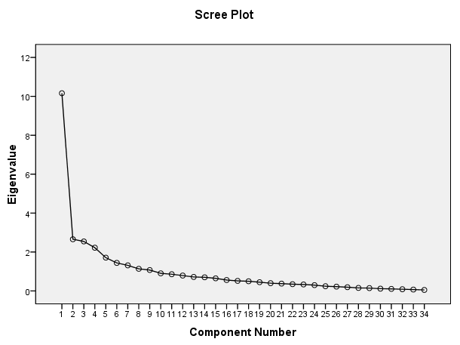

Figure 1: Scree plot for preliminary analysis

The final chosen factor solution, obtained through principal component analysis and equamax rotation, accounts for 56.7 percent of the total variance and consists of five factors with strong factor loadings of .61 or higher for the constituent items. Both the KMO coefficient and Bartlett’s test (see Table 1) suggest that factor analysis is appropriate and the results are acceptable. Further analyses using maximum likelihood factoring and/or varimax and direct oblimin rotational methods produced near identical results, thus reinforcing the researchers’ confidence in this factor model.

Kaiser-Meyer-Olkin Measure of Sampling Adequacy |  | .725
Bartlett's Test of Sphericity | Approx. Chi-Square | 1617.528
Bartlett's Test of Sphericity | df | 561.000
Bartlett's Test of Sphericity | Sig. | .000

Table 1: KMO and Bartlett’s Test

Table 2 shows the eigenvalues after rotation and the percentage of variance accounted for by each of the five factors extracted using the above-mentioned criteria.

Factor | Rotation Sums of Squared Loadings
Factor | Eigenvalue | % of Variance | Cumulative %
1 | 5.087 | 14.961 | 14.961
2 | 4.252 | 12.505 | 27.466
3 | 4.148 | 12.200 | 39.666
4 | 3.185 | 9.367 | 49.033
5 | 2.617 | 7.696 | 56.729

Table 2: Percentage of variance explained by factors after rotation

References

Atkinson, J.W. (1964). An introduction to motivation. Princeton, NJ: Van Nostrand.
Au, S.Y. (1988). A critical appraisal of Gardner’s socio-psychological theory of second-language (L2) learning. Language learning, 38, 75–100.
Chan, W.M., & Chi, S.W. (2008). Foreign Language Learning in a Multicultural Setting – With a Special Focus on the Korean Language Programme at the National University of Singapore (CLS Working Papers No. 15). Singapore: Centre for Language Studies.
Clyne, M. (2003). Towards a more language-centred approach to pluralingualism. In J-M. Dewaele, H. Baetens Beardsmore, A. Housen, L. Wei (Eds.), Bilingualism: Beyond Basic Principles (pp. 43–55). Clevedon: Multilingual Matters
Gardner, R.C. (2004). Attitude/motivation test battery: International AMTB research project. Retrieved from http://publish.uwo.ca/~gardner/docs/englishamtb.pdf
Hair, J.F., Anderson, R.E., Tatham, R.L., & Black, W.C. (1998). Multivariate data analysis with readings (5th ed.). Englewood Cliffs, NJ: Prentice-Hall.
Palit, H.N. (2007). A framework for pervasive web content delivery (Doctoral dissertation). National University of Singapore, Singapore.
Sew, J.W. (2010, June). Blogging Malay in foreign language education. Paper presented at ICT2010 Singapore Conference on Inspired Solution, Empowering Learning, Singapore.

NPR’s (or National Public Radio) online news can be accessed at the following URL: http://www.npr.org/

