Formatting Information for CLaSIC 2012 Conference Proceedings

All presenters are requested to submit their papers by 19 October 2012 for inclusion in the conference proceedings, which will be published in digital format (with ISBN). Manuscripts that reach us after this date can no longer be included in the proceedings. Only soft copies of manuscripts in Microsoft Word 2007 or 2003 Document should be sent to clasic2012@nus.edu.sg as e-attachments.

Files should be saved under filenames according to the following format.

familyname_givenname.docx
(E.g., chan_waimeng.docx)

Papers with multiple authors should be named after the first author only.

One copy of the proceedings will be distributed to each registered participant. Please format your manuscript according to our style sheet. Please check your manuscript carefully for spelling and grammatical errors. Authors are responsible for the linguistic and factual accuracy in their own manuscripts. Your cooperation is much appreciated as this will reduce production time and minimize possible formatting errors.

For any enquiries, please email us at the above address.

Style Sheet for CLaSIC 2012 Proceedings

Document Format: Microsoft Word (2007 or 2003)

Paper Size: A4

Margins: Left and right, 2.5 cm, Top and bottom: 3 cm

Length: The file size for the manuscript should not exceed 2MB.

Font/Sizes: Times New Roman 12 pt. for main body, references,
11 pt. for captions of tables and figures

Line Spacing: Single (unless otherwise indicated)

Please refer to the examples in the following pages for more information.

Top/Bottom Margin: 1.28”
Left/Right Margin: 1”

2 blank lines (Times New Roman 12pt.) between title and authors' names

TITLE OF PAPER IN TIMES NEW
ROMAN, 16 PT., UPPER CASE, BOLD AND CENTRED

Author in Times New Roman, 13 pt.
(e-mail address in Times New Roman, 11 pt.)
1 blank line (Times New Roman 12pt.) between author and co-author
Author’s Institution, Country of Institution in Times New Roman, 11 pt.

Co-author in Times New Roman, 13 pt.
(e-mail address in Times New Roman, 11 pt.)
Author’s Institution, Country of Institution in Times New Roman, 11 pt.
3 blank lines (Times New Roman 12pt.) between affiliations and abstract

Abstract (Times New Roman, 12 pt., bold)

Abstract should be in a single paragraph and between 150 and
200 words; Times New Roman, 11 pt., full justified
2 blank lines (Times New Roman 12pt.) between abstract and first heading

- First Level Heading in upper and lower cases, Times New Roman, 12 pt., bold, hanging indent, app. 0.2”
Use a decimal system for all headings and sub-headings, e.g. 1, 1.1, 1.1.1, 1.1.2 etc.
Avoid using more than 3 levels of headings

Leave one line between the heading and first line of text.

  - Second and All Subsequent Level Headings in upper and lower cases, Times New Roman, 12 pt., bold, italic.

Citations in parentheses with commas separating individual
information, e.g. (Howard, 2003) or "Howard (2003)
…" with direct quoting from a source, include page numbers, e.g.
(Jahn, 1998, p. 35) in APA Style (6th ed.)

Figures

All graphs, diagrams and photos are labeled as figures and numbered in running order. Figures and captions (Times New Roman, 11 pt., Boldface) are centred on the page. Captions appear one blank below the figures

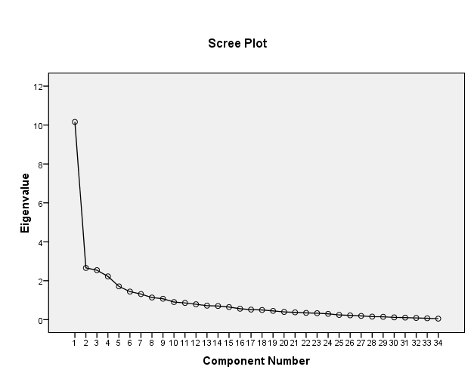
Fig. 1. Scree plot for preliminary analysis

Tables

Tables and captions (Times New Roman, 11 pt., Boldface) are centred on the page. Caption appears one blank line above the table.

Table 1. KMO and Bartlett’s Test

Kaiser-Meyer-Olkin Measure of Sampling Adequacy |  | .725
Bartlett's Test of Sphericity | Approx. Chi-Square | 1617.528
Bartlett's Test of Sphericity | df | 561.000
Bartlett's Test of Sphericity | Sig. | .000

Footnotes

Use footnotes sparingly in Times New Roman, 10 pt.

References

References in alphabetical order to follow APA Publication Manual, 6th ed., Washington, DC).

Article in a Periodical:
Montrul, S., & Slabakova, R. (2003). Competence Similarities between Native and Near-native
Speakers. Studies in Second Language Acquisition, 25, 35-398.

Books/Monographs:
Stevick, E.W. (1989). Success with foreign languages. Hertfordshire: Prentice Hall.

Ward, C., & Renandya, W. (Eds.) (1999). Language teaching: New insights for the language
teacher. Singapore: SEAMEO Regional Language Centre.

Book Chapter:
Prabhu, N.S. (1999). Teaching is at most hoping for the best. In C. Ward & W. Renandya (Eds.),
Language teaching: New insights for the language teacher (pp. 48-57). Singapore:
SEAMEO Regional Language Centre.

Article in an Online Periodical:
Wolfe, E.W., & Manalo, J.R. (2004). Composition medium compatibility in a direct writing
assessment of non-native English speakers. Language Learning and Technology, 8, 53-65.
Retrieved from http://llt.msu.edu/vol8num1/wolfe/default.html

Online Document:
Noblitt, J.S. (1995). Cognitive approaches to listening comprehension. Retrieved from
http://www.unc.edu/cit/iat-archive/noblitt3.html

Unpublished Conference Paper
Sew, J.W. (2008, April). Language pedagogy in the global age: A Malay experience. Paper
presented at ASAIHL Conference on Borderless Education, Bangkok, Thailand.

Unpublished Thesis
He, Y. (2008). Exploring the Chinese blogosphere: The motivations of blog authors & readers
(Unpublished master’s thesis). National University of Singapore, Singapore.

